**Name**: Daniel Schenker

**Position on team**: Lead Programmer

**Area of focus**: Pathfinding, File Manager, Camera

**Relevant Experience**:

* Relevant Programming Languages: GML, C, C++, C#
* Relevant Game Engine Knowledge: Game Maker, Unity
* Relevant Artistic Tools: Paint, Paint.net
* Good at physics, math, logic, overall architectural design.
* Good at communicating with non-programmers and understanding non-programming topics.
* Pays fine attention to small details, thus resulting in being able to write clean, legible code.

**School Schedule**:

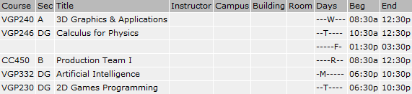

**Non-School Schedule:**

See attached excel sheet: DanielSchenker_Schedule.xlsx

**Regular hours per week that you will contribute to GPW (Min 1 hour per in-class hour)**:

6

**Total including extra flex hours per week that you may be able to contribute**:

10